# Networking

 IP Address is a unique number assigned to device for communication.  We have two types of IP

 Public IP:

 This is unique number across internet.

 Generally depending on internet connection type (Static ip & Dynamic Ip)  Multiple devices sharing a network might share some public ip

 Private IP:

 This is a unique number for a network  Each device gets a unique ip

 Principles

 Two devices in a network can communicate only when they belong to same network, to communicate with other networks they need extra configurations/devices

 IP Address is combination of  Network id

 Host id

# Private IP Address

 Private IP addresses have a reserved ip range

192.168.0.0 to 192.168.255.255

172.16.0.0 to 172.31.255.255

10.0.0.0 to 10.255.255.255

# How does a system get an Ip Address in Private Network

## Home network

 Typically, we would have a wifi router in a home where a network range is predefined

 When a device is connected to a wifi via a network interface, DHCP program running in wifi router will assign an ip address to the network interface

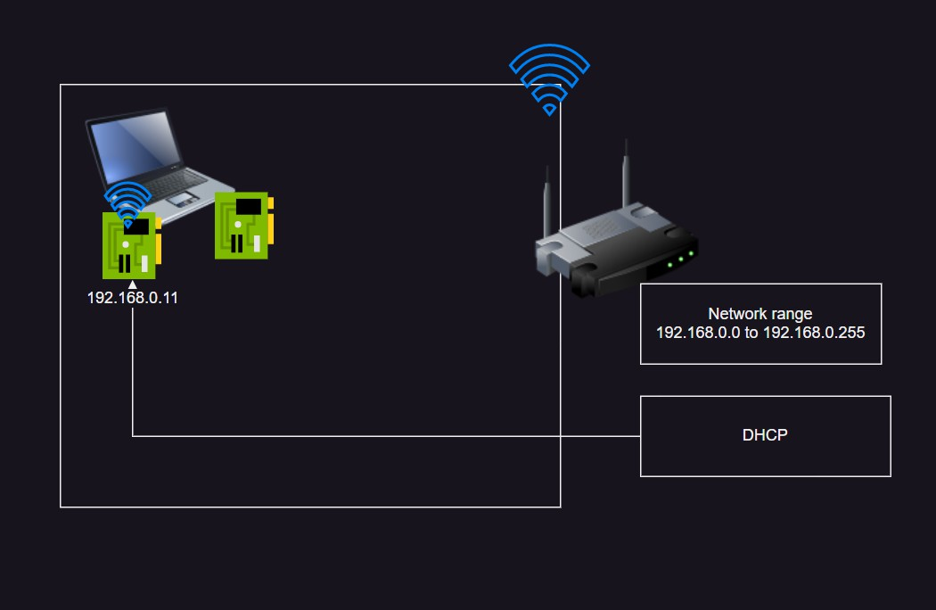

 This ip can be used to communicate with the device.

## Enterprise Network

 Typically, every enterprise network has two servers

 DHCP (Dynamic Host Configuration Protocol) Server:

 Assign available ipaddress to the servers or devices  DNS (Domain Name System) Server

 Maintain name to ip address mapping

# Finding Network id and Host Id from Ipaddress

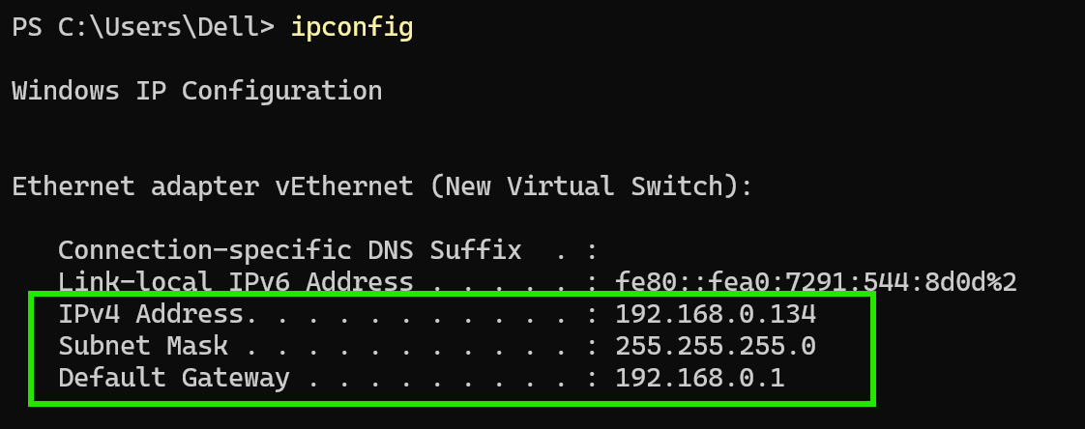 On your laptop, execute the command ipconfig

 We have the following information  ip address

 Subnet mask

 Default Gateway

Generally, Default Gateway is ipaddress of your router Lets find network id and host id

ip: 192.168.0.134

sm: 255.255.255.0

Find out the octets where subnet mask has 255's and write ip value and whatever is left is host id

network id: 192.168.0

host id: 134

Example 2

ip: 192.168.0.133

sm: 255.255.255.0

nid : 192.168.0 (Fixed)

hid : 133 (Variable = 8 bits)

Example 3

ip: 192.168.0.17

sm: 255.255.0.0

nid: 192.168

hid: 0.17 (Variable = 16 bits)

Example 4

ip: 10.0.0.16

sm: 255.0.0.0

nid: 10

hid: 0.0.16 (Variable = 24 bits )

IP Address are of two sizes  ip v4

X.X.X.X

range:

 ip v6

IP v4: Is a 32 bit number divided into 4 octets

0.0.0.0 to 255.255.255.255

**ipv4 vs ipv6**

IPv4 uses 32-bit addresses (e.g., 192.168.1.1) and supports ~4.3 billion devices, while IPv6 uses 128-bit addresses (e.g., 2001:db8::1) and supports virtually unlimited devices with better security.

DHCP (Dynamic Host Configuration Protocol) assigns IP addresses automatically to devices on a network, ensuring they can communicate without manual configuration.

DNS (Domain Name System) translates domain names (e.g., google.com) into IP addresses, allowing users to access websites using easy-to-remember names instead of numeric addresses.

Dynamic Assignment (via DHCP)

A DHCP server automatically assigns an available IP address to a device when it connects to the network.

Common in-home networks, offices, and ISPs.

The IP can change over time (lease-based).

Static Assignment (Manual Configuration)

A fixed IP address is manually set by a user or network admin.

Used for servers, printers, and critical infrastructure.

Does not change unless manually updated.

**Can one system can have multiple IP address**

Yes, a single system can have multiple IP addresses. This can happen in several ways:

1. Multiple Network Interfaces (NICs) – If a system has multiple physical or virtual network interfaces, each can have its own IP address.

2. Multiple IPs on a Single Interface – A single network interface can be assigned multiple IP addresses (called "IP aliasing" in Linux or using "Secondary IP" in cloud environments like AWS, Azure, and GCP).

3. IPv4 and IPv6 – A system can have both an IPv4 and an IPv6 address simultaneously.

4. VPN and Virtual Adapters – If a system is connected to a VPN or uses virtual network adapters (e.g., Docker, Hyper-V, or VMware), it may have additional IP addresses.

5. DHCP and Static IP – In some network configurations, a system may receive multiple IPs, such as one from DHCP and another manually assigned.